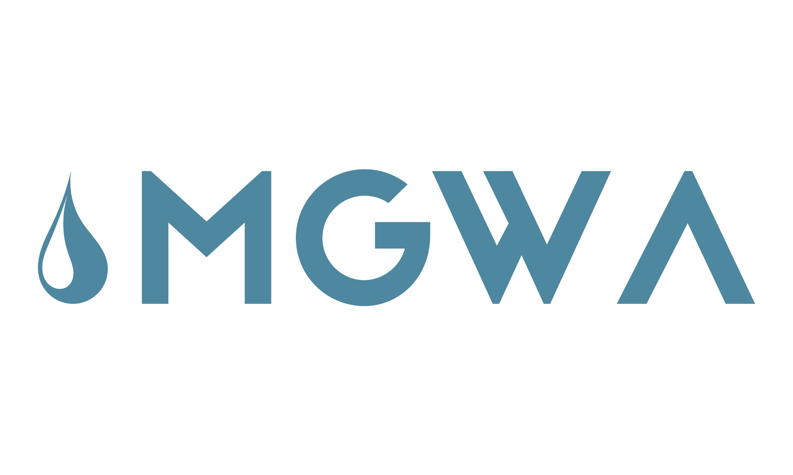
Minnesota Ground Water Association Foundation
Gil Gabanski Student Scholarship
www.mgwa.org

Purpose
The Minnesota Ground Water Association (MGWA) and the MGWA Foundation (MGWAF) are pleased to announce the continuation of the Gil Gabanski Scholarship to support and encourage undergraduate and graduate students in groundwater science-related fields. Multiple $2,000 scholarships will be awarded this year to undergraduate and graduate students enrolled at accredited colleges or universities in Minnesota or adjoining states or provinces. The goal of this scholarship is to alleviate a portion of educational costs and provide mentorship, while also increasing student interest in groundwater-related professions. The Gabanski Student Scholarships are made in honor of Gil Gabanski, the co-founder and former president of the Minnesota Ground Water Association. Gil had a profound impact on the groundwater and geosciences communities in Minnesota. He helped build our organization to what it is today and was always passionate about helping and mentoring students.

Where and How to Apply
Submit your completed application form to office@mgwa.org no later than January 31st, 2025.

Application Criteria
Eligibility: Applicants must be enrolled as an undergraduate or graduate student in good academic standing in groundwater science or advocacy, with significant coursework in the geosciences at an accredited college or university in Minnesota or an adjacent state or province including Iowa, North Dakota, South Dakota, Wisconsin, Michigan, Manitoba, or Ontario.
Aims: The goal of this scholarship is to alleviate a portion of the educational costs for students, while also increasing their interest in the professions of hydrogeology, groundwater geology, and related topics, as well as provide early-career mentorship.

Award Amount: Multiple ($2,000) scholarships will be awarded this academic year.

Application Deadline: Your complete application must be received prior to January 31st, 2025.

Use of Scholarships: Scholarship awards may be applied toward tuition, fees, field work, field camp, or other costs directly related to their field of study.

Basis of Award: The Scholarship Committee (composed of officers and members of MGWA and MGWAF) will make the final selection of students to receive the scholarships based on their review of the application form, responses to short answer questions, and transcript(s). Previous scholarship recipients are not eligible to apply; however previously unsuccessful applicants may apply providing they still meet the application requirements.
Your application will be evaluated on your:
- Commitment to and interest in a groundwater-related career
- Demonstrated need for and plans to use scholarship funds
- Future goals and plans to achieve them
- Ability to communicate your interest in and path to a groundwater-related career

How to Apply: Submit your completed application form, unofficial undergraduate and graduate academic transcript(s), and answers to short questions electronically to office@mgwa.org.
Applicants are responsible for submitting ALL the required materials by the deadline. MGWAF is not responsible for notifying applicants of incomplete or missing information. Please put your first and last name in the file name you submit.

The scholarship recipients will be announced annually by the end of March. The recipients will also be announced at the Spring MGWA conference and in the MGWA newsletter. The recipients will be awarded a one-year student membership to MGWA and will be invited to write an article in the MGWA newsletter describing their research or interest in hydrogeology and how they used the funds. Recipients may have the opportunity to present a poster or a presentation at an upcoming MGWA conference or serve on the scholarship committee in the future. Any questions about this process or suggestions for its improvement should be addressed to the MGWA Foundation Scholarship Committee at office@mgwa.org.

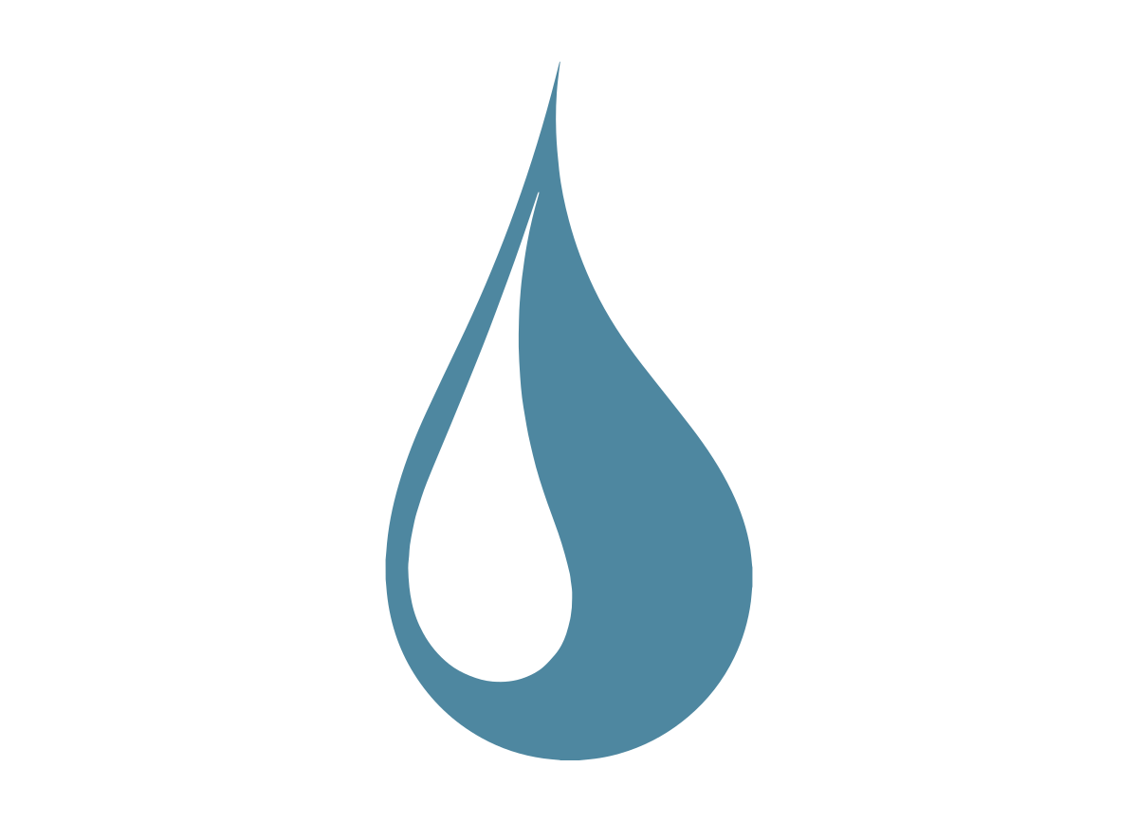
Gil Gabanski Student Scholarship
Award Application Form
Application deadline is January 31st
Applicant’s Name
Home Address ________________
City: State: Zip Code:
Phone:

E-mail address:

Name of and address of undergraduate institution:

Name and address of graduate institution (if applicable):

Completed degree (if applicable):
Expected degree:
Major:
Expected date of graduation:

Scholarship Application Questions
The following questions are designed to help us understand your motivation and interest in a groundwater-related career, as well as challenges you may have faced or are overcoming as you pursue your groundwater-related studies. Please limit responses to 1200 characters or about 250 words per question.

Non-Academic Responsibilities and Challenges
We would like to know what non-academic responsibilities you have had in your family, your work, or in the community. What have you learned from these experiences?

- Personal Achievement
Please describe a meaningful personal achievement and how it has influenced your life.

- Your Path
What led you to choose a path to groundwater-related science?

- Academic, Career, and Life Goals and Plans
Tell us about your future goals and plans as they relate to your education and career in a groundwater-related field.

- Scholarship Funds
How do you plan to use the scholarship funds? How will this scholarship help you?

Make sure to submit:
- Application Form
- Answers to each of the five questions (answer each question separately)
- Unofficial transcripts

